# Copyright 2015 Google Inc.

#

# Licensed under the Apache License, Version 2.0 (the "License");

# you may not use this file except in compliance with the License.

# You may obtain a copy of the License at

#

# http://www.apache.org/licenses/LICENSE-2.0

#

# Unless required by applicable law or agreed to in writing, software

# distributed under the License is distributed on an "AS IS" BASIS,

# WITHOUT WARRANTIES OR CONDITIONS OF ANY KIND, either express or implied.

# See the License for the specific language governing permissions and

# limitations under the License.

# [START app]

from flask import Flask

app = Flask(__name__)

@app.route('/')

def hello():

"""Return a friendly HTTP greeting."""

return 'Hello World!'

if __name__ == '__main__':

app.run(host='127.0.0.1', port=8080)

# [END app]

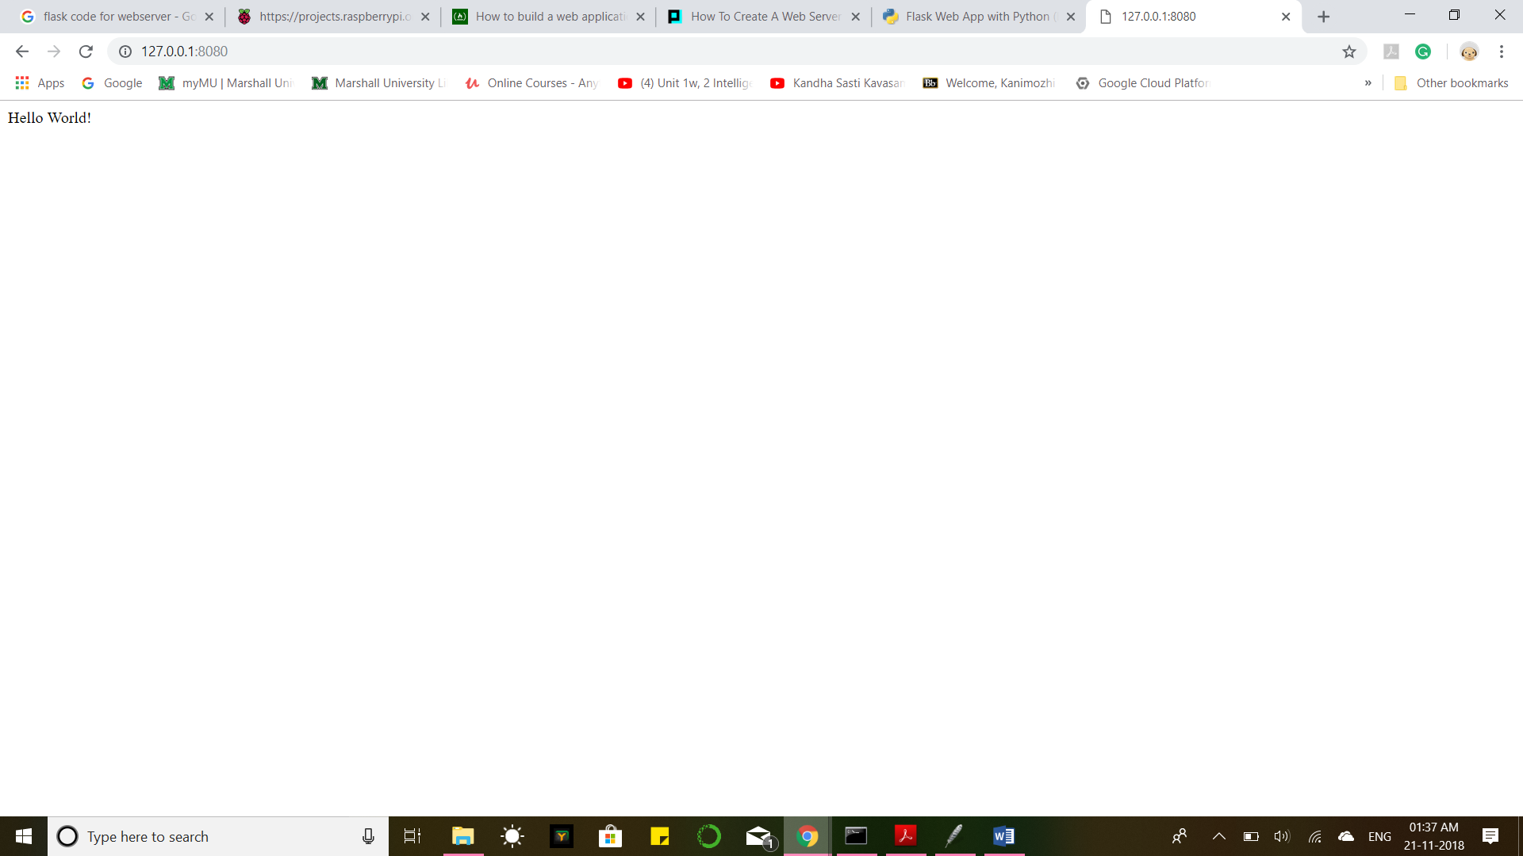

Flask Project in PyCharm:

from flask import Flask, render_template

app = Flask(__name__)

@app.route('/')

def hello_world():

return render_template("homepage.html")

if __name__ == '__main__':

app.run()

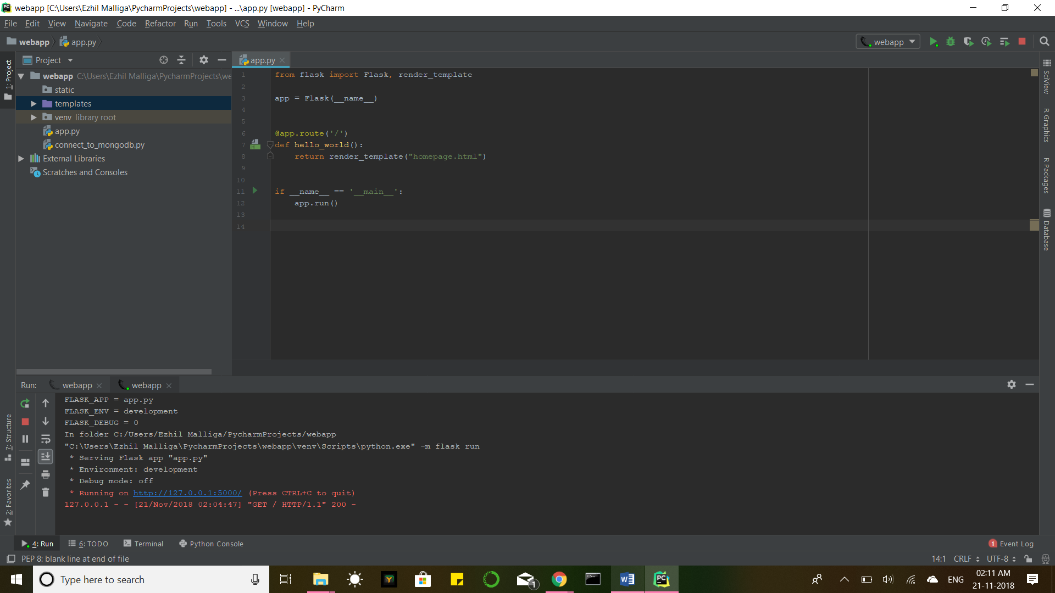

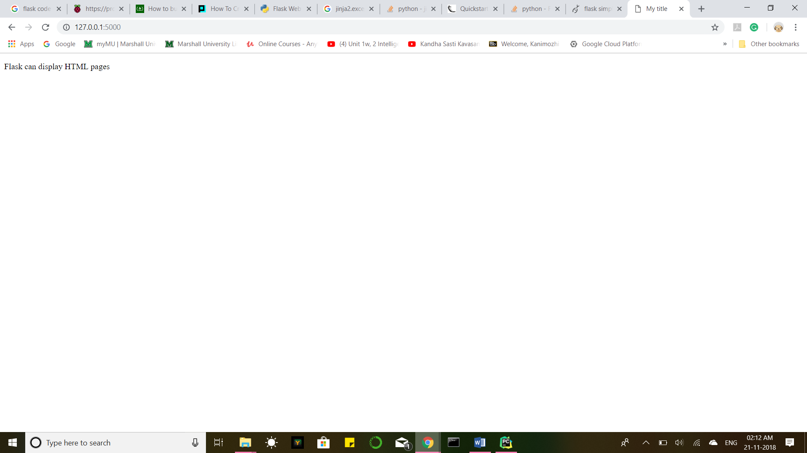

PyCharm Code:

from flask import Flask, render_template

app = Flask(__name__)

@app.route('/')

def hello_world():

return render_template("homepage.html")

if __name__ == '__main__':

app.run()

homepage.html

<!DOCTYPE html>

<html>

<head>

<meta http-equiv="Content-Type" content="text/html; charset=UTF-8">

<title>Home Page</title>

</head>

<body style ="background-color:#F7DC6F;">

<h1 style="color:dodgerblue;" align="center">

Welcome to My Web App </h1>

<br>

<h3 align="center"> Login</h3>

<form action="dataretrieval.jsp">

<pre align="center">

Enter User ID : <input type="text" name="userid" placeholder="Enter UserID">

Enter password : <input type="text" name="pwd" placeholder="Enter Password">

<input type="submit" value="SUBMIT">

</pre>

</form>

</body>

</html>

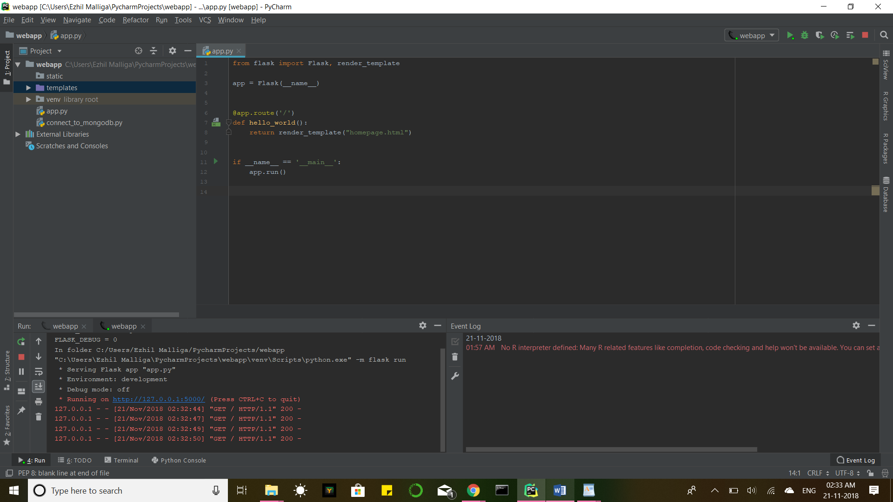

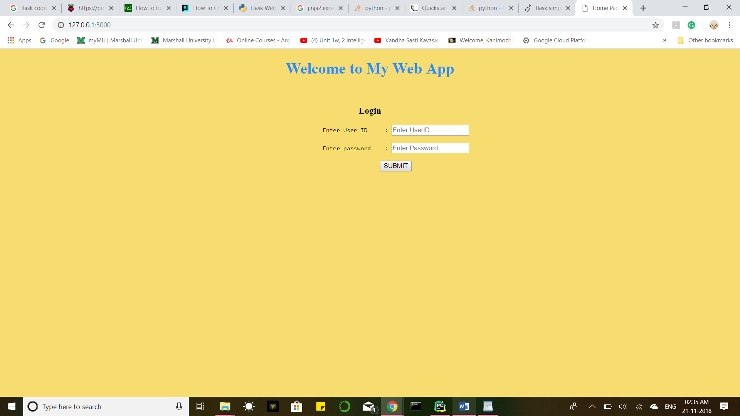

<form>

<p id="demo">Hello</p>

<pre align="center">

<button type="button" onclick="myFunc()">Search</button>

<button type="button" onclick="myFunction()">Insert</button>

<button type="button" onclick="myFunction()">Update</button>

<button type="button" onclick="myFunction()">Delete</button>

<a href = "file:///C:/Users/Ezhil%20Malliga/PycharmProjects/webapp/templates/search.html">click here </a>

</pre>

</form>

<script>

function myFunc() {

window.location.href = "file:///C:/Users/Ezhil Malliga/PycharmProjects/webapp/templates/search.html";

}

function myFunction() {

document.getElementById("demo").innerHTML = "Value Changed";

}

</script>